**Steps To Extract Youtube Comments Using Google Sheet**

**Step 1:** Open A Google Sheet and add a blank new spreadsheet.

**Step 2:** Paste the Video Id in the first cell and save the spreadsheet.

(Note: we can extract the video Id link from any youtube video link like: if link is like: <https://www.youtube.com/watch?v=fUK94jOFwBc&list=PLEiEAq2VkUUKL3yPbn8yWnatjUg0P0I-Zasssde&index=5>

Then the Video id will be the string after v=, means in this case the video id should be fUK94jOFwBc.)

**Step 3:** Go to the Extension >> Apps Script and Click over there. (refer below image)

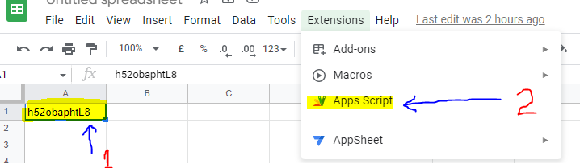

**Step 4:** Click on the Plus button of the Services Tab.

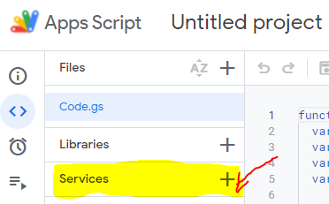

**Step 5:** Add the Youtube Service by choosing Youtube Data API v3 and then Add it.

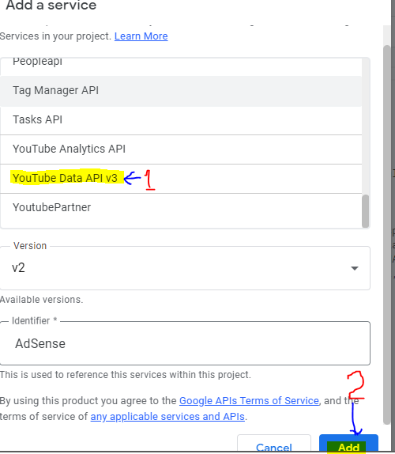

**Step 6:** Go to the Code.gs Page andwrite the code (shared over Github link) to extract the comments.

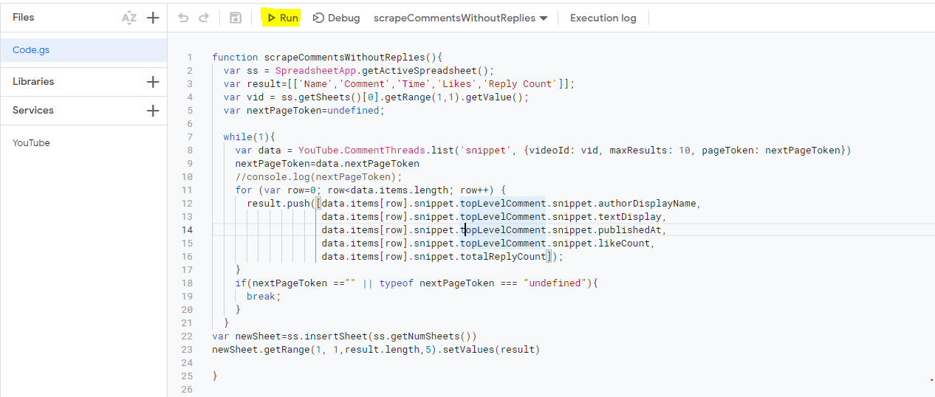

**Step 7:** Save using(Ctrl + S) and then click over the Run Button. It will extract all the comment data and save it into another sheet in the same spreadsheet. PFA Output Format.

